**Do zoos help or harm animals?**

What do you think? Do you agree or disagree? Perhaps you can

think of ideas for both sides of this topic.

**Write to convince a reader of your opinions:**

* Start with an introduction.
* Write your opinions on this topic.
* Give reasons for your opinions. Explain your reasons for your opinions.
* Finish with a conclusion. Sum up your writing to convince a   
  reader of your opinions.

**Remember to:**

* 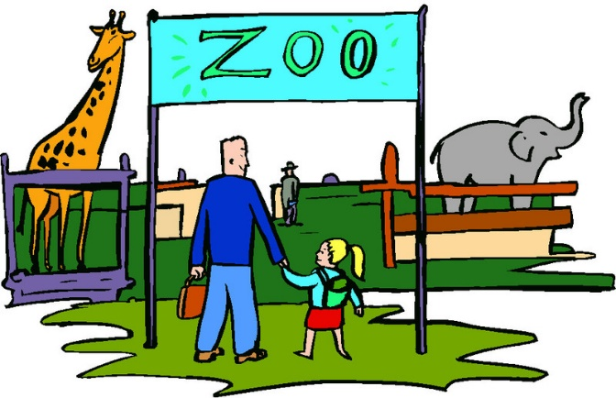Plan your argument
* Choose your words carefully to convince a reader
* Write in full sentences
* Pay attention to spelling and punctuation
* Use paragraphs to organise your ideas
* Check and edit your writing